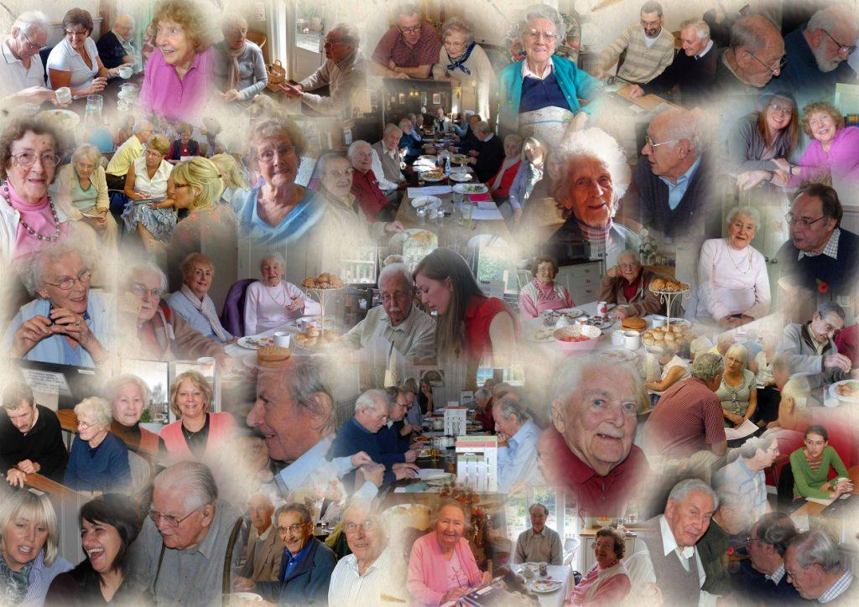

Volunteer Pack
January 2021
Welcome
Thank you for registering an interest in joining the Linking Lives Scheme
We are a local befriending service connecting volunteers with elderly people for friendship and support throughout east Purbeck.
We hope that the information in this booklet will answer some of your questions and encourage you to send off your application form to us!
Why Volunteer for the Linking Lives Scheme?
Loneliness and social isolation has become a huge problem in our nation and on a local level. It can affect people of all ages but perhaps the most vulnerable are our ageing population who may have:
- Problems getting out of the house due to poor mobility
- Health concerns which mean they need more help
- Family who may have moved away or work full-time
- Loved ones who may have died
Experts agree that social isolation is the biggest challenge facing our ageing society and many older people fear loneliness more than lack of money or deteriorating health. We hope that you can help us achieve our aim of tackling this issue through friendship, support and social activities.
Our Background
The model of the Linking Lives Scheme has been operating successfully in Wokingham Borough, Berkshire since 1998 where over 150 older people regularly receive visits from a volunteer specifically assigned to them. Using a ‘Community Franchise’ approach, we have established a similar scheme to serve the Swanage area. Our scheme is locally managed with local accounts and we receive advice and support from the charity in Wokingham when necessary. The Swanage scheme arose from a community audit conducted by Churches Together in Swanage and District and is supported by the churches, though operated as a community project encouraging participation by people of all faiths and none. We are now part of Swanage and Purbeck Development Trust who provide charitable status as well as wider community links.

The Swanage Linking Lives Team
Chair: Sarah Bamber
Clients & Volunteers Supervisor: Roger Seaman
Treasurer: Alan Dominy
Secretary: Caroline Powell
Committee: Nicola Rodgers, Patricia Liles, David Edgington, Gail Mercer, Jackie Gould

Phone: 07495 534171
e-mail: swanage@linkinglives.uk

21 Commercial Road
Swanage
BH19 1DF

www.sandp.org.uk/link-visiting

Offering Friendship and Support across
east Purbeck

Swanage Linking Lives is part of Swanage and Purbeck Development Trust (www.sandpdt.org.uk)
and a franchise of Linking Lives UK (www.linkinglives.uk)
Registered Charity No: 1162662

What happens next - our recruitment process?
It is vital that older people can feel confident in the scheme. They need to know that all of our volunteers are trustworthy and capable. To that end we need to perform some checks, these are:

Application Form - All volunteers are asked to complete a brief application form. You will find this at the back of the pack.
- References – We take up two character references. These cannot be relatives and it is helpful if one has known you in a professional capacity.
- Informal interview – an opportunity for you to find out about the befriending role as well as for us to understand your background and what you can offer.
- Disclosure and Barring Service Check (replaced the old CRB check) – we need you to complete a DBS form and allow us to copy your ID documents. After a few weeks you will receive your disclosure certificate and you will need to provide us with a copy.
- Induction Training – we require all volunteers to attend a 2 hour training session designed to equip you in your befriending role.
Once all of the above steps have been completed we will be in a position to link you to someone who needs a visitor.
How the linking process works
We receive referrals from many of the key organisations in the area who work with elderly/isolated people. Some referrals also come from family members or the individual themselves. The following process takes places:
- Referral Form – We receive basic details about the person (Link friend) who needs a visitor.
- Initial Assessment – The coordinator will visit the Link friend as soon as possible to get to know them and to assess whether he/she fits within the scheme’s criteria. If they do not fit our criteria every effort is made to refer them to other relevant agencies.

- Volunteer Assigned – We endeavour to find a suitable volunteer who would work well with the Link friend. We take into account personality, experience, interests, availability and geography.
- Introductory Visit – The coordinator will introduce the volunteer to an assigned Link friend. This will take place in the Link friend’s home. Assuming this meeting goes well, Link friend and volunteer will then agree regular ongoing visits.
- Regular Visits Begin - Provided the above proceeds satisfactorily, visits will continue according to the availability of the volunteer. This is usually once a week/fortnight for around an hour or so. Visits take the form of informal conversations over a cup of tea/coffee and aims to provide crucial support to their Link friend.

More Information
If you would like more information about Linking Lives Swanage or have any questions as to whether volunteering is for you, do contact us at our office. Recent research suggests that volunteers are just as likely to benefit as those they help, with 90% reporting personal satisfaction through volunteering. You could make the difference in breaking down social isolation and help to build our local community.

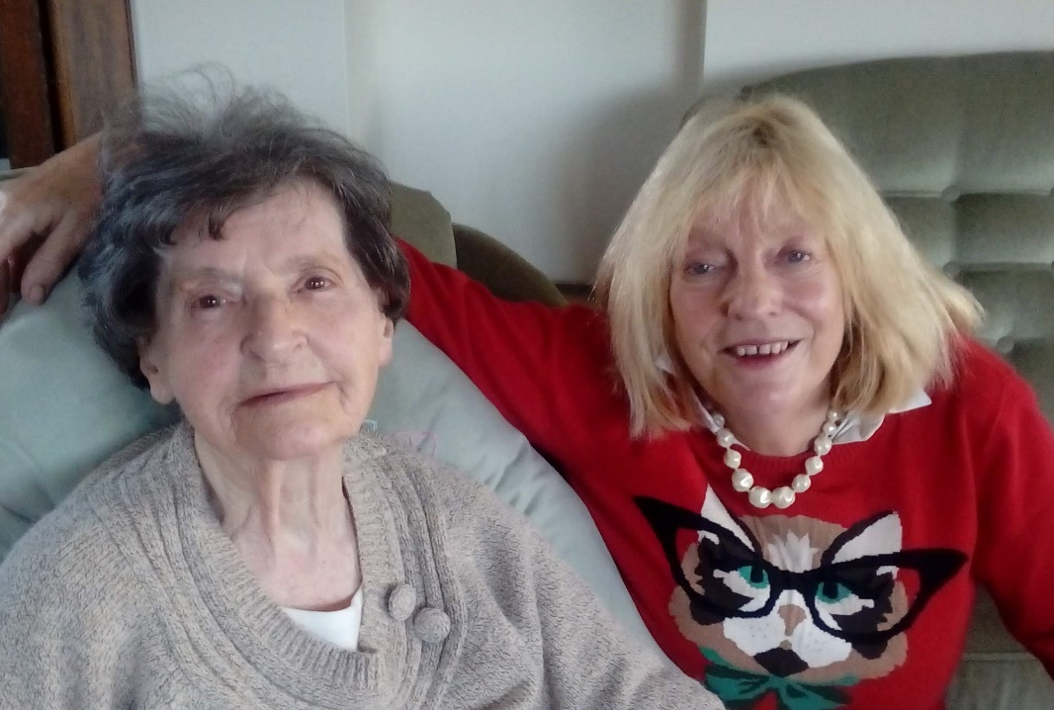

Guidelines and Volunteer Agreement
- Volunteers are a guest of the Link friend and should respect the opinions and beliefs of all Link friends. It is inappropriate to impose your faith or beliefs on Link friends.

- As a Link representative we expect our volunteers to act with respect and courtesy towards other service providers, family members and Link staff.

- Physical tasks should be avoided – i.e. personal care, gardening, odd jobs etc. You’re there to give quality time and provide a listening ear!

- Link friends may be benefiting from paid services from other organisations. Volunteers must not obstruct the delivery of these services without prior arrangement from family members or Link staff.

- Confidentiality must be maintained at all times to ensure no breach of trust between volunteer and Link friend.* Any worries or concerns should only be shared with your coordinator.

- We encourage our Volunteers to help our Link friends maintain their independence by doing activities together. A balance needs to be kept between befriending your Link friend and allowing them to become dependent on you.

- It is advisable for you as a volunteer to inform a member of your family or a friend of your whereabouts when engaged in visiting.

- You should not accept monetary or valuable gifts other than donations to the scheme. Exceptions are small gifts of nominal value, e.g. flowers or chocolates, as refusal may cause offence.

*Exceptions to this can occur. If you are concerned about possible abuse or criminal activity please speak to the coordinator immediately.

Guidelines and Volunteer Agreement

We would like to ensure the scheme runs smoothly, is of real benefit to our Link friends and rewarding to you. The purpose of this agreement is to clarify what we would ask of YOU (the Volunteer) and what you can expect of US. Failure to comply could result in a volunteer dismissal.

What we ask of you
- To visit your Link friend on a regular basis (approximately an hour or so once a week or once a fortnight
- To treat your Link friend with respect, politeness, kindness and honesty
- Where appropriate, we encourage you to do things together, this might include things like going shopping together, baking together, preparing light lunches together, going out for coffee, pottering in the garden. The emphasis is on doing the activity together in order to maintain independence and promote friendship.
- To respect your Link friend’s right to confidentiality
- Monitor your Link friend’s health and well-being and contact the coordinator if you have concerns as soon as possible. (We have a resource of other care agencies and organisations that can help with any practical needs) .
- If you cannot visit at the time arranged, you will make every effort to let your Link friend know as soon as possible
- Wherever possible you will attend Link group meetings and training
- If you wish to stop visiting your Link friend you will give us as much notice as possible
- To follow and work within the guidelines and volunteer agreement in this Volunteer pack

What you can expect from us

- There will be discussion with you prior to placing you with someone

- You will be introduced to your Link friend by your coordinator.

- That after a trial period we will review with you and your Link friend how the visits are progressing and if they should continue

- We will discuss your visits with you, both formally and informally and wherever possible provide you with help or information regarding other service provision that would benefit your link friend

- We will provide occasional training events relevant to your befriending role

- If you have a complaint about Linking Lives you can contact the coordinator who will endeavour to speedily resolve any issues

- If we have a complaint about you, we will endeavour to discuss this with you as soon as possible. If issues remain unresolved we will act in line with our formal complaints procedure

- If you wish to stop visiting or leave the scheme, we will help you to finish in a planned way.

All details in this form will be treated as strictly private and confidential. Please write clearly in black ink, completing all sections of the application. Once completed, please return to Roger Seaman, Linking Lives Swanage, 21 Commercial Road, Swanage, BH19 1DF
Personal Details
Mr/Mrs/Miss/Ms/Other:
First Name/s:
Surname:
Date of Birth:
Address:
Postcode:
Contact No (H): (M)
Email:
Religious Affiliation (if any):
Languages spoken fluently:
How did you hear about us?
Availability
How often would you be available? (Please circle) Weekly / Fortnightly
Are there particular days that you would prefer?

Preferences
Can you get to anywhere in Swanage? Would you be willing to travel to outlying villages? ________________________
Occasionally volunteers take our Link friends out for coffee or to Garden Centres etc. Would you be happy to drive your Friend out if appropriate? Yes / No (Please see note re car insurance and driving licence below.)
What hobbies or interests do you have that may help us in matching you to a Link friend?
What do you hope to get out of volunteering for Linking Lives? ___________ ________________________________________________________________________
________________________________________________________________________

Would you be interested in befriending someone with;
- Dementia? (Further training may be available) Yes / No /Not sure
- Short-term memory problems? Yes / No /Not sure
- Learning disability? (further training may be available) Yes / No /Not sure
- Physical disability who is not necessarily elderly? Yes / No /Not sure

Health
Do you have, or have you had any medical problems which may affect your work as a volunteer? (If ‘yes’ please give details) Yes / No

Relevant Details
What experience, skills or qualifications do you have which may be relevant to your role as a volunteer?

Convictions
Have you had any criminal convictions? Yes / No
If ‘yes’ please give details on a separate sheet.
This post meets the requirements in respect of exempted questions under the Rehabilitation of Offenders Act 1974, any applicants for this post who are offered employment or who become volunteers for this organisation will be subject to a Disclosure and Barring Service check before the appointment is confirmed. This will include details of cautions, reprimands or final warnings as well as convictions. A criminal record will not automatically bar a person from successfully taking up this post.
References
Two references will be required. Please provide their details below. One must be from work or a similar, more ‘official’ or public relationship (e.g. councillor, doctor, vicar).
Name: Mr/Mrs/Miss/Ms
Address: Postcode:
Contact No:
Email:
How long have you known this person? _______ In what capacity? ______________

Name: Mr/Mrs/Miss/Ms
Address: Postcode:
Contact No:
Email:
How long have you known this person? _______ In what capacity? ______________
Use of Car for Volunteering
If you do opt to drive your car to take your Link Friend on an outing please confirm (tick box) that you have checked with your car insurance company that you are covered for this purpose. Please also bring your driving licence to the office so it may be copied for our records.
Confidentiality Agreement
In the course of your visiting you will have access to confidential information and records about your Link friends and sometimes other Volunteers. It is therefore vital that you treat all information about your Link friends and other volunteers as confidential.
Our Link friends and Volunteers must be able to have confidence that personal information is never released.
Please sign this Confidentiality Agreement to confirm that you accept your responsibility to maintain the confidentiality of your Link friend and other Volunteers
Signed Date
Declarations
I confirm the information in this application form to be correct and any misleading or falsification of information may be proper cause for rejection or termination of this placement.
I give permission for the information on this application form to be held on a computer.
All information gathered as part of the core operation of Swanage Linking Lives is considered to be a ‘legitimate interest’ of our organization in providing this service. This is outlined in more detail within our Privacy Policy which can be viewed by clients, volunteers and other stakeholders at any time. Your personal data will only be used for the purposes of your role within Linking Lives Swanage
Yes / No
Have you read and do you accept the volunteer agreement? Yes / No
Are you willing for us to arrange a DBS check on you? Yes / No
When the DBS registration is completed you will receive a certificate through the post. Please bring this into the office so it may be copied for our records.
(If you have a subscription to the DBS Update register please provide your reference
number …………………………………… so that we can access your portable DBS check)
Signed Date

Once completed, please email or return this form to;
Roger Seaman, Swanage Linking Lives, 21 Commercial Road, Swanage, BH19 1DF
Phone: 07498 743036; e-mail: lvs.volunteers@outlook.com

