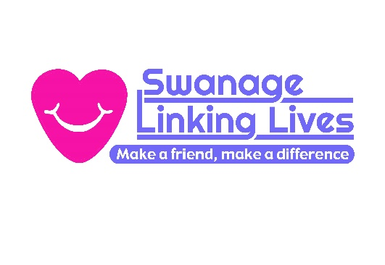
Our 1:1 visiting service is designed for older people who live in Swanage and east Purbeck and who experience loneliness and social isolation. We accept referrals for those who live independently or in sheltered accommodation and lack a strong social network. They must be capable of forming friendships and not have complex needs.
Please be sure that the person referred does want a visitor before submitting this form.

- Basic Information
Name:
Preferred name:
Date of Birth (dd/mm/yyyy): Gender:
Address:
Town: Swanage Postcode:
Accommodation:

Hints on finding the address:
(if difficult)

Contact No (H): (M)
Name of GP: GP No:
Name of GP Practice:
First Emergency Contact: Tel No:
Second Emergency Contact: Tel No:
Next of Kin: Tel No:
- Other Information
Relevant Medical History:

(Continue on A4 sheet if not enough space)
Reason for Referral:

Does the client suffer from short term memory loss? (Has there been a diagnosis?)

Name of Social Worker:
Is there a Personal Care Budget: Yes / No If Yes, does it cover Social isolation: Yes / No
Are there any communication difficulties?

Suggestions for activities?

- Person Referring
Name:
Agency/Organisation/ Relationship to person referred:
How long have you known the person referred?
Contact No:
Email:
The person referred has agreed to this referral
Signed: Referral Date:
Data Protection Statement
Please note that all information contained within this document will be stored and utilised within the guidelines of GDPR regulations and – where necessary - the appropriate consent will be obtained from those about whom we hold information.

Once completed, please return this document to:
Swanage Linking Lives, 21 Commercial Road, Swanage BH19 1DF
e-mail: swanage@linkinglives.uk Tel. No. 07495 534171
Registered Charity. No: 1162662
Company Limited by Guarantee
Registration No: 8743407
Registered Address:
Herston Cross House 230 High Street Swanage BH19 2PQ

Swanage Linking Lives is part of

